

**PROJECT 4**

**“Smart IoT Networking in Agriculture”**

Arranged by : Group 4

1. Gafrilatif Aviandi Putra Adnanta (2120010053)

2. Muhamad Farhan Budiana (2120010203)

3. Muhammad Zidan Satrio (2120010105)

Class : 2 ISA 3

Faculty : Mr. Kevin Harada

**Continuing Education Center for Computing and Information**

**Technology**

**Faculty of Engineering, University of Indonesia**

**Kampus Baru UI Depok 16424**

**2021**

**Developed by**

Name :

**Bobby Ibnu Perkasa** (1820010045)

**Dimas Arsyad Hidayat** (1820010055)

**Millenia Saharani** (1820010122)



**PROJECT ON**

EMPLOYEE ATTENDANCE APPLICATION

Batch Code : 2 ISA 3

Start Date : July 11th, 2022

End Date : July 27th, 2022

Name of the Coordinator : Mr. Kevin Harada

Names of Developer :

1. Gafrilatif Aviandi Putra Adnanta (2120010053)

2. Muhamad Farhan Budiana (2120010203)

3. Muhammad Zidan Satrio (2120010105)



**Smart IoT Networking in Agriculture**

This is to certify the report, titled **Smart IoT Networking in Agriculture** embodies original work done by Gafrilatif Aviandi Putra Adnanta, Muhamad Farhan Budiana and Muhammad Zidan Satrio in fulfilling the project 4 assignment in CCIT-FT UI.

Coordinator,

**Mr. Kevin Harada**



**CERTIFICATE**

Praise be to the presence of Allah, SWT. who has helped us in making this project because without the pleasure of it we will not be able to make this project. we also thank to Mr. Kevin Harada as our lecturer and mentor in making this project entitled **Smart IoT Networking in Agriculture.** Hopefully what we have made can be useful in the future.

Best Regards,

**Authors**



**ACKNOWLEDGEMENT**

**SYSTEM ANALYSIS**

**System Summary :**

This project describes how to use Cisco Packet Tracer. Cisco Packet Tracer is a Packet Tracer is a cross-platform visual simulation tool designed by Cisco Systems that allows users to create network topologies and imitate modern computer networks. The software allows users to simulate the configuration of Cisco routers and switches using a simulated command line interface. In packet tracer create a network design ioT by connecting with intermediate network devices

The Internet of Things (IoT) describes the network of physical objects – a.k.a. “things” – that are embedded with sensor, software, and other technologies for the purpose of connecting and exchanging data with other devices and systems over the internet. For example our project will be the example of Smart IoT Networking on Agriculture.

**TOPOLOGY**

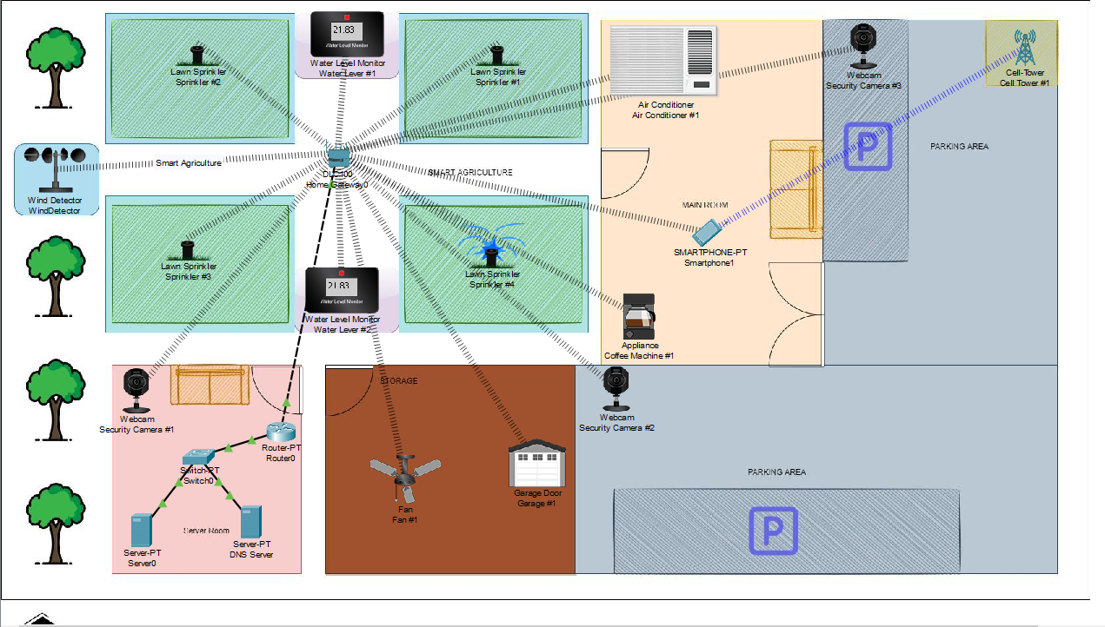

List of IP Address:

|  |  |  |  |  |
| --- | --- | --- | --- | --- |
| DEVICE NAME | INTERFACE | IP ADDRESS | SUBNET MASK | DEFAULT GATEWAY |
| DNS Server | FA1/1 | 192.168.25.2 | 255.255.255.0 | 192.168.25.1 |
| IoT Server | FA2/1 | 10.0.0.2 | 255.0.0.0 | 10.0.0.1 |
| Switch0 | FE0/0 and FE0/1 | 192.168.10.1 and 192.168.25.1 | 255.255.255.0 | N/A |
| Cell Tower #1 | 3G/4G Server1 | N/A | N/A | N/A |
| Router0 | FE0/0 and FE0/1 | 192.168.10.1 and 192.168.25.1 | 255.255.255.0 | N/A |
| Smartphone1 | Wireless0 | DHCP Assigned | DHCP Assigned | 192.168.5.1 |
| HomeGateway0 | Wireless | 192.168.10.2 | 255.255.255.0 | 192.168.10.1 |
| Ceiling Fan | Wireless0 | DHCP Assigned | DHCP Assigned | DHCP Assigned |
| Sprinkler #1 - #4 | Wireless0 | DHCP Assigned | DHCP Assigned | DHCP Assigned |
| Fan #1 | Wireless0 | DHCP Assigned | DHCP Assigned | DHCP Assigned |
| Water Lever #1 and #2 | Wireless0 | DHCP Assigned | DHCP Assigned | DHCP Assigned |

**IP ADDRESS**

**IP ADDRESS**

|  |  |  |  |  |
| --- | --- | --- | --- | --- |
| DEVICE NAME | INTERFACE | IP ADDRESS | SUBNET MASK | DEFAULT GATEWAY |
| WindDetector | Wireless0 | DHCP Assigned | DHCP Assigned | DHCP Assigned |
| Security Camera #1 - #3 | Wireless0 | DHCP Assigned | DHCP Assigned | DHCP Assigned |
| Garage #1 | Wireless0 | DHCP Assigned | DHCP Assigned | DHCP Assigned |
| Coffee Machine #1 | Wireless0 | DHCP Assigned | DHCP Assigned | DHCP Assigned |
| Air Conditioner #1 | Wireless0 | DHCP Assigned | DHCP Assigned | DHCP Assigned |

**IOT**

in this project we are group 4, will present Smart IoT Networking in Agriculture. The content that we present contains the concept of agricultural irrigation that we can control wirelessly via our smartphones and we also present several other items that we can also control from our smartphones.

* First we need to do is make and configurate both Server-PT including DNS Server and Server0.

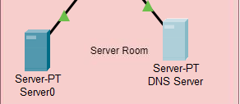

* after that, select the static option on the Gateway/DNS IPv4 and for example fill the Default Gateway 192.168.25.1 and DNS Server 192.168.25.2 as well as the FastEthernet0 with 192.168.25.2

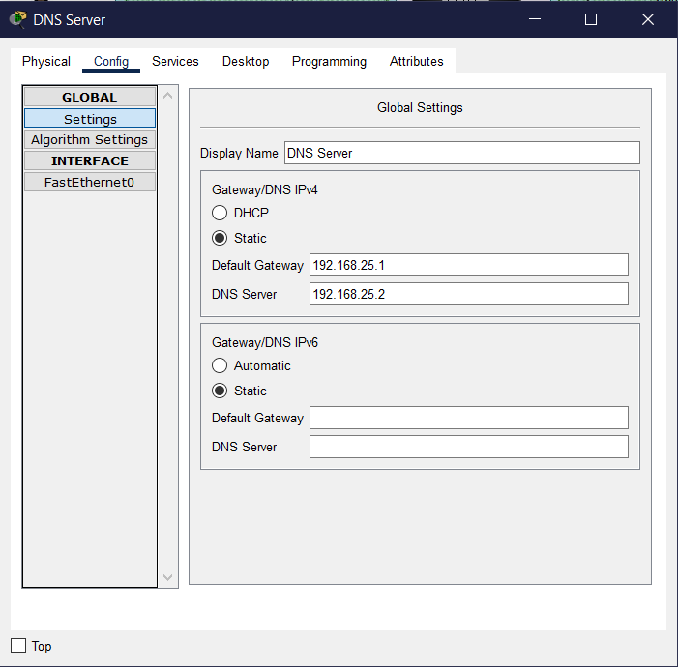 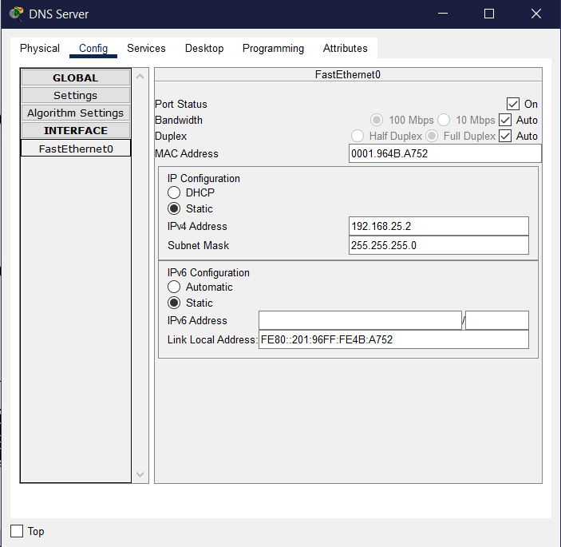

**IOT**

* Moving on to the Switch, go to CLI and fill this command in IOS Command Line Interface

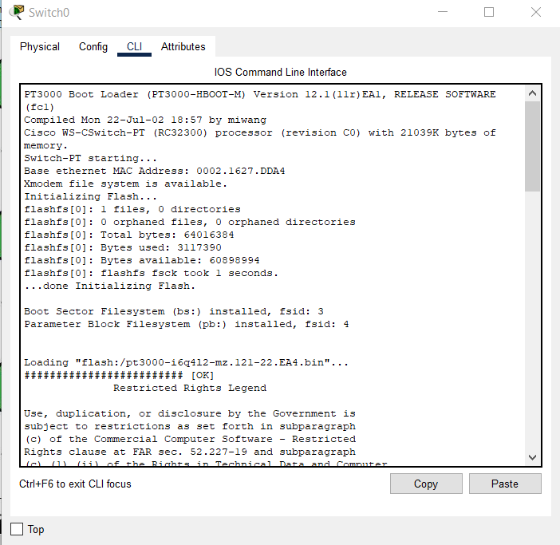 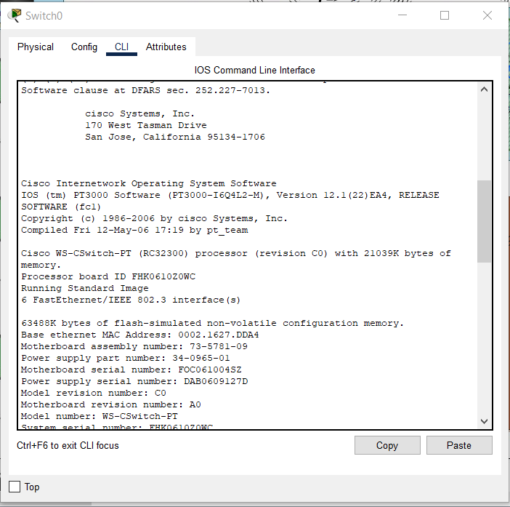

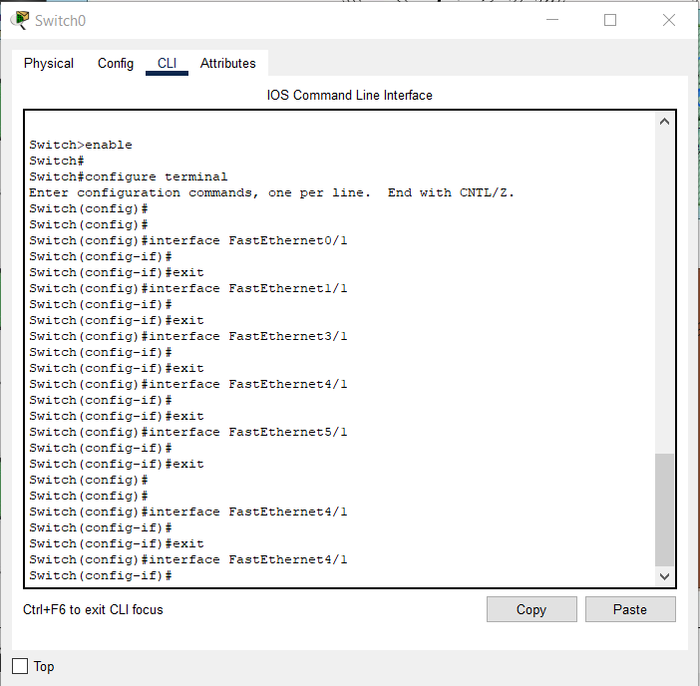

**IOT**

* Next step, similar as before, go to CLI and type this command

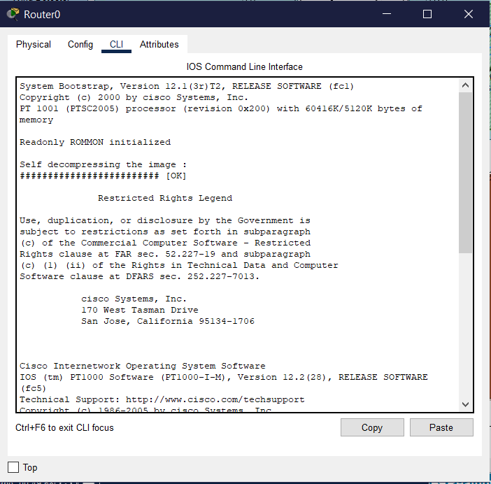 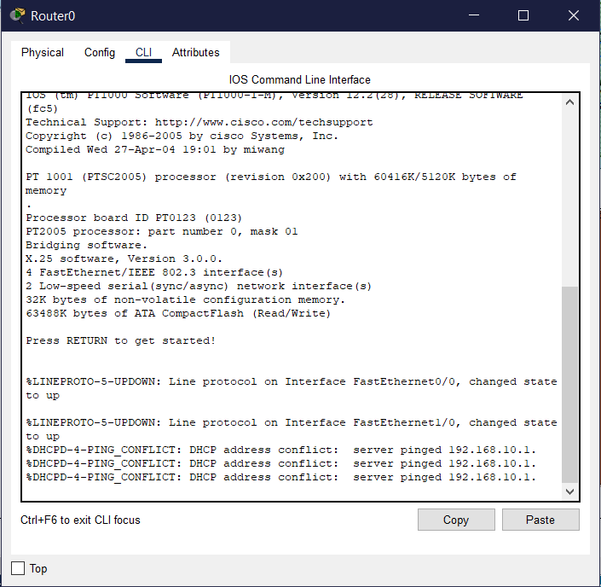

* And it will appear in the interface

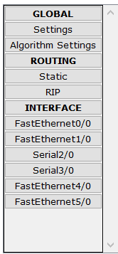

**IOT**

* The next step is to configure the Home Gateway which is used for bridges network access between connected local area network (LAN) hosts to a wide area network (WAN). The IP we used is 192.168.5.1 with 255.255.255.0 subnet mask.

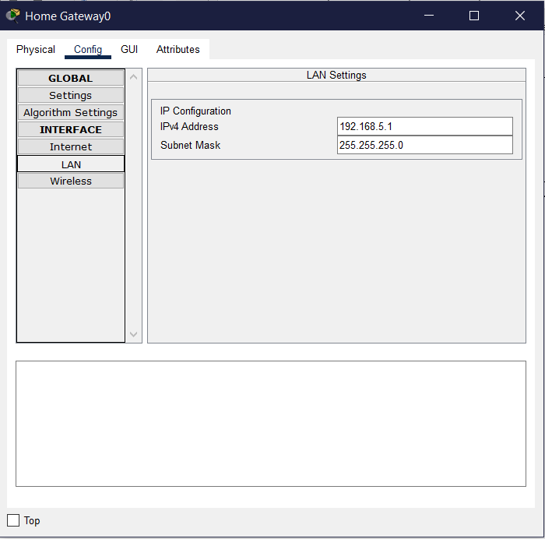

**IOT**

* Now we will connect the smartphone to the cell tower with 3G/4G/Cell
* Change the provider name into ptcellular

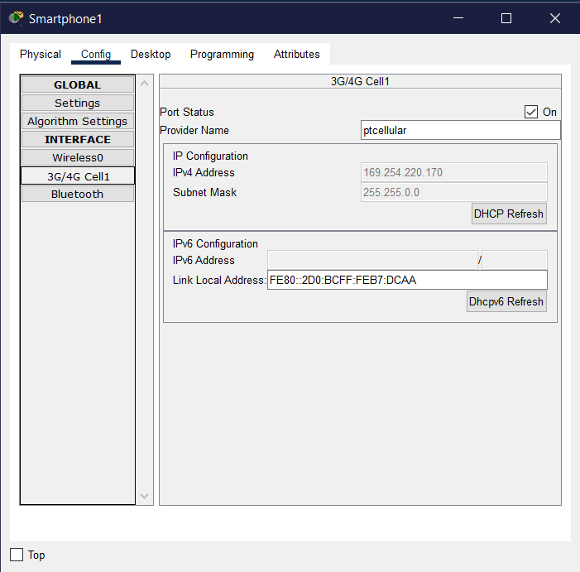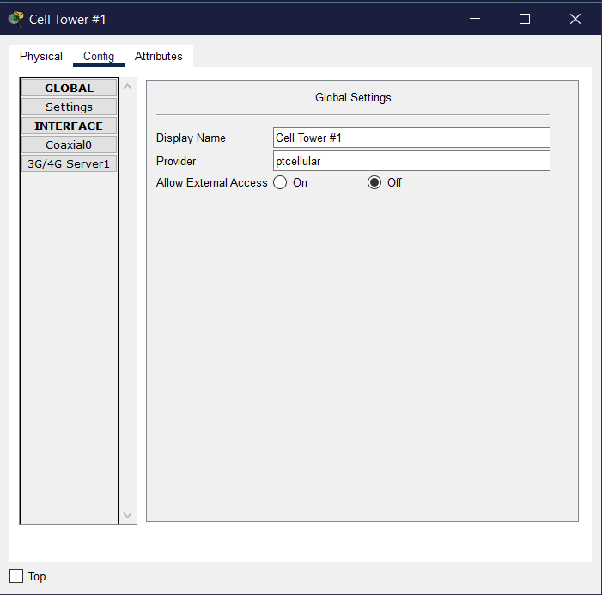

* The internet is already connected

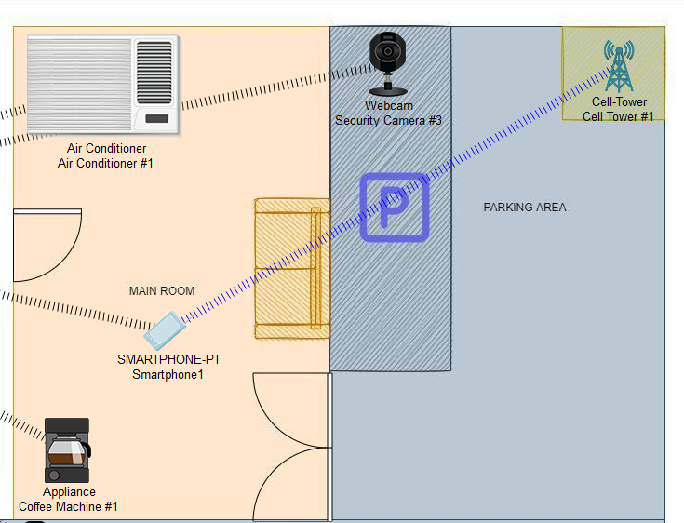

**OUTPUT**

* Click the Smartphone1 icon

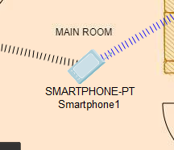

* Go to desktop and choose Web Browser

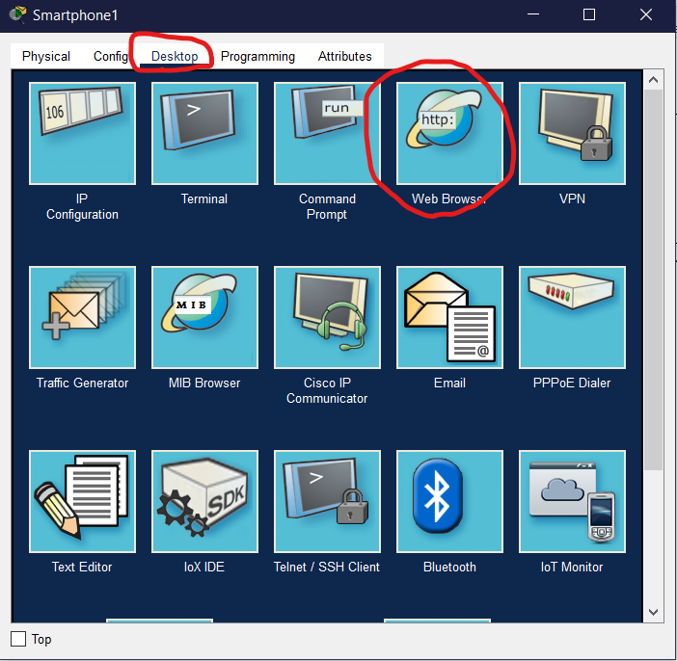

**OUTPUT**

* And then, write your IP address in the URL, for example ours is 192.168.5.1 after that click GO.

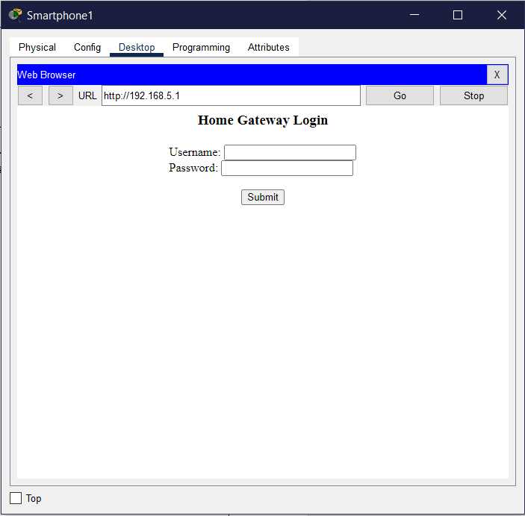

* Now enter your Username and Password and click Submit, for example ours is Username : admin and Password : admin

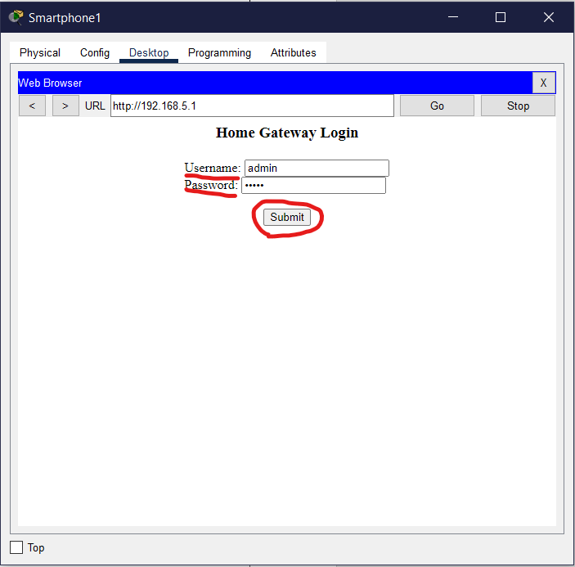

**OUTPUT**

* If the username and password is correct, it will appears the Home menu of IoT devices contains all of the devices we used. All of our devices is using DHCP without any changes.

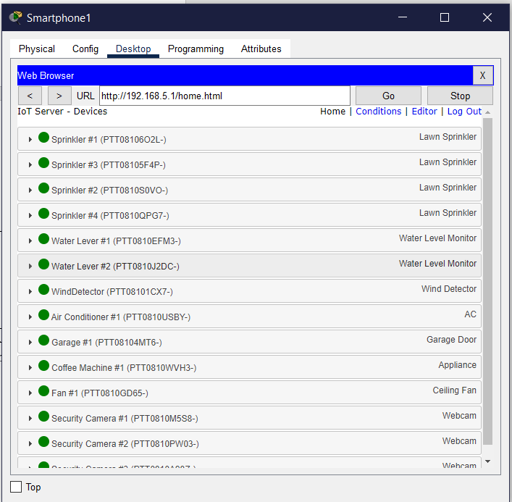

**OUTPUT**

* For example, we run our four sprinklers which we use to water our trees regularly. For that, we determine certain conditions. To make a certain conditions go to “Conditions”

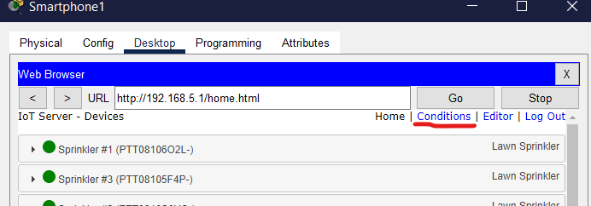

* Click add and then select the conditions you want to apply

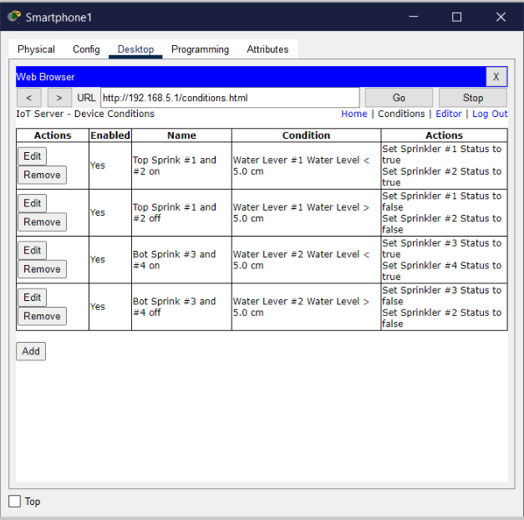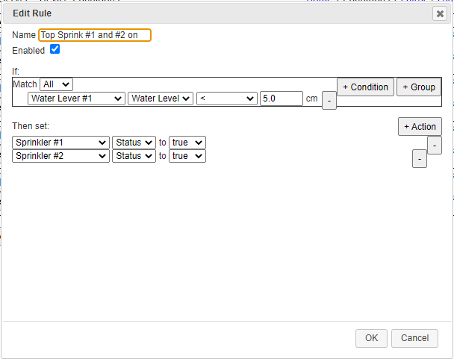

**OUTPUT**

* And the sprinkler is successful and ready to use along with certain conditions

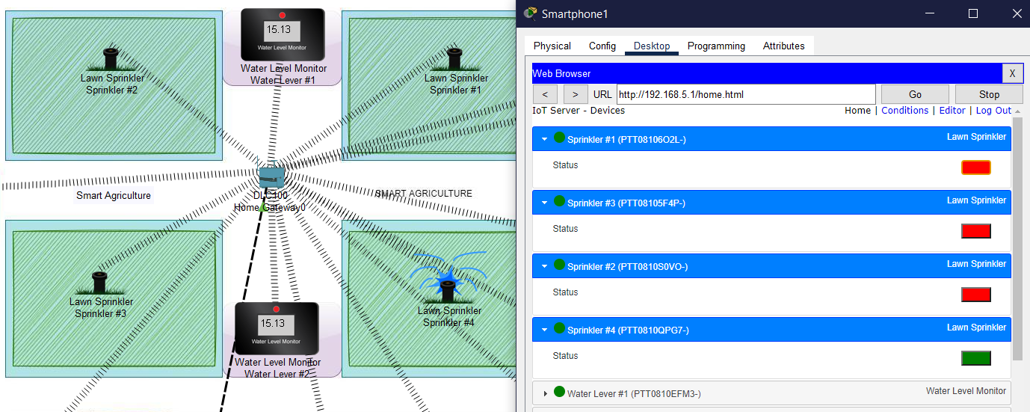

* For another example, we have our Security Camera, but for this one we don’t need to set condition. Just make sure it is connected to the DHCP.

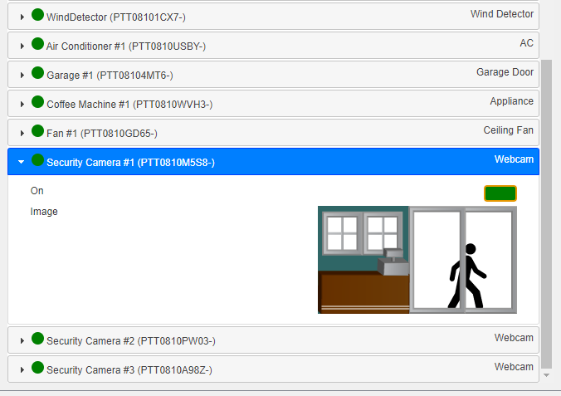

**CONFIGURATION**

* Hardware : AMD Ryzen 7 4800H with NVIDIA RTX 2060 6GB GDDR5, 16GB DDR5, 512GB SSD .
* Operating System : Microsoft Windows 10 Home
* Software : Cisco Packet Tracer